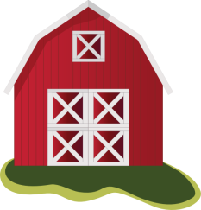

Do you know where your food comes from?
If you think the grocery store… this will make you think again!
Arizona Agriculture Literacy

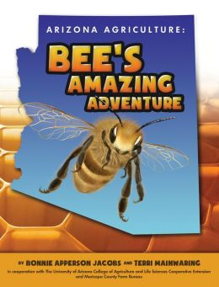
Food doesn’t just magically appear
at the grocery store
A book on Arizona
agriculture for
elementary*
grades!

Join the Chino Library’s virtual presentation!
Great for Families – Free, Interactive, & Educational!
Friday, May 14th at 10-11am at:
https://tinyurl.com/azagadventure
RSVP to RLaurence@chinoaz.net or 928-636-9115

