

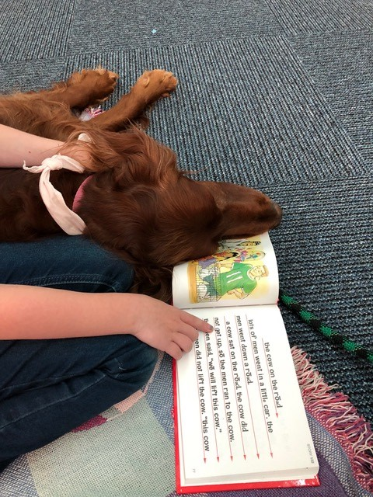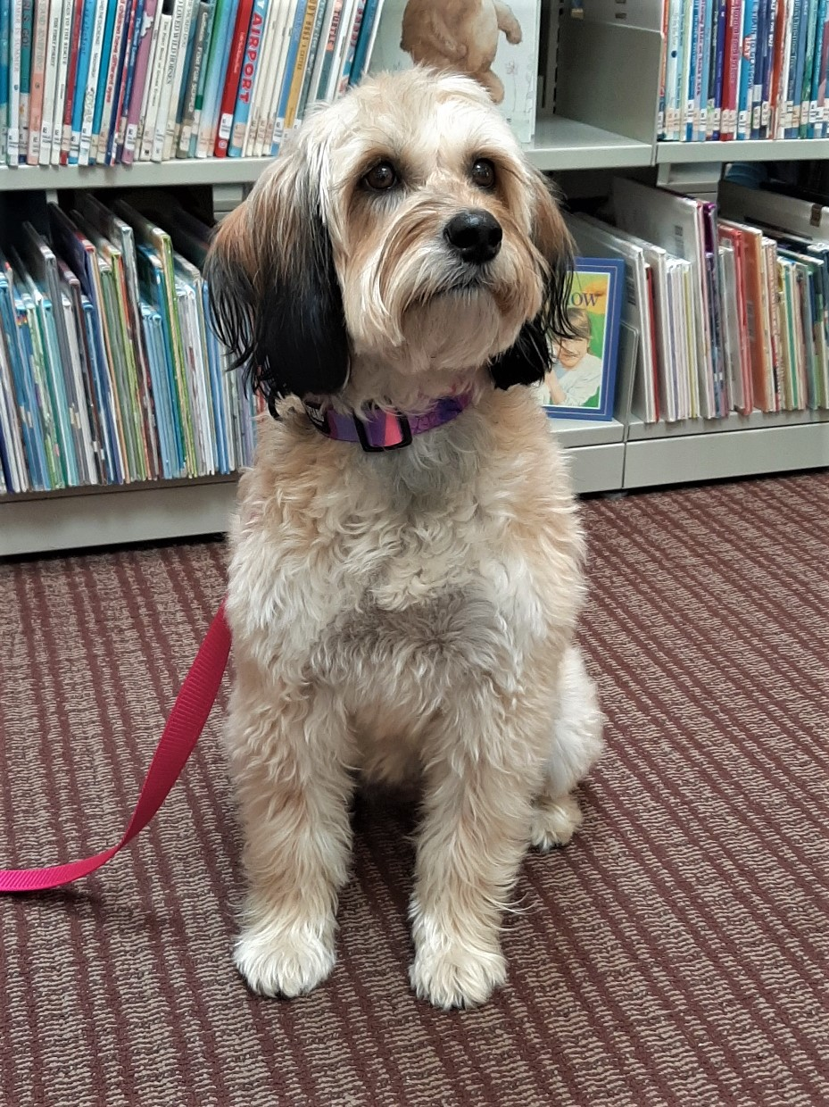

***UPDATE!* 🡪**

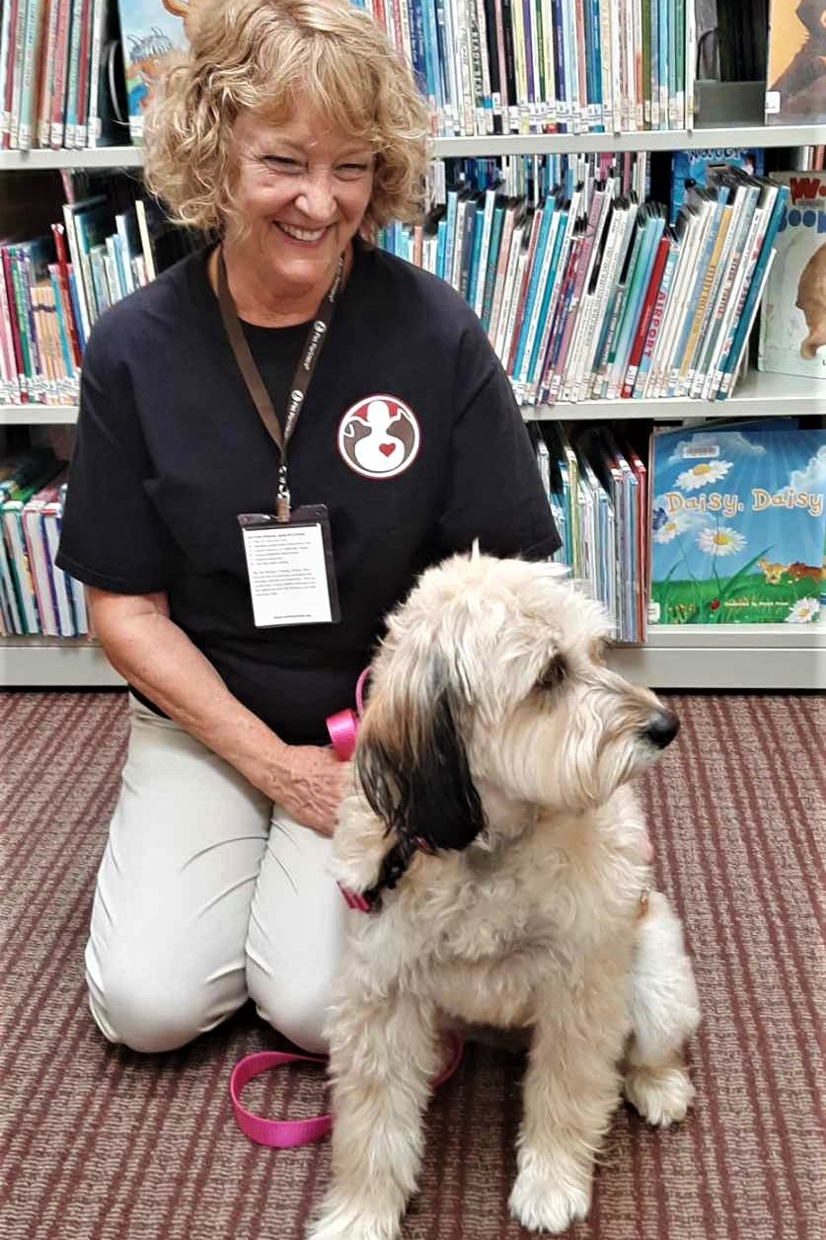

**Kids – Practice your reading with GREAT Furry Listeners at Chino Valley Public Library!**  
 2nd Tues of each month 2:30-4:30pm 4th Mon of each month 3-4pm  
 (Frankie & Ms. Pat) (Megan & Ms. Deb)

