FREE ORIGAMI CLASS
All Materials Provided,
For ages 8 – 98!
Thursday August 18, 3-5pm
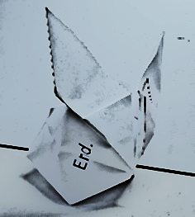
Drop by after school and make a:
1) Blow-up Bunny/Waterbomb
2) Easy Modular Wreath
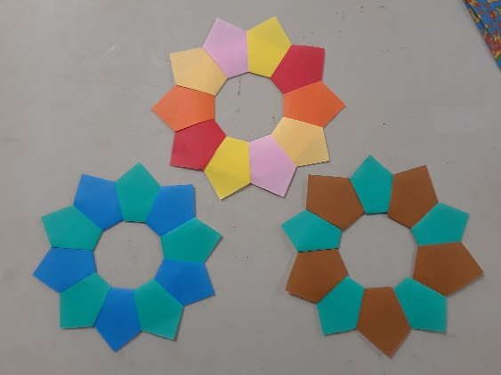
Anyone can attend, but the models
are best suited to ages 8 and up
and adults are always welcome.
Origami, it's not just for kids!
Regular classes taught by Instructor Chila Caldera, held at:
Chino Valley Public Library 1020 W Palomino Rd Chino Valley AZ 86323, 928-636-9115 RLaurence@chinoaz.net

FREE ORIGAMI CLASS
All Materials Provided,
For ages 8 – 98!
Thursday August 18, 3-5pm
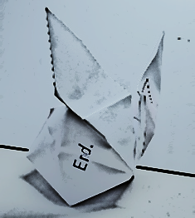
Drop by after school and make a:
1) Blow-up Bunny/Waterbomb
2) Easy Modular Wreath
Anyone can attend, but the models
are best suited to
ages 8 and up
and adults are
always welcome.
Origami, it's not just for kids!
Regular classes taught by Instructor Chila Caldera, held at:
Chino Valley Public Library 1020 W Palomino Rd Chino Valley AZ 86323, 928-636-9115 RLaurence@chinoaz.net

