**Kids! Do you love dogs?   
Do you love reading?   
-*OR*- Need to practice your reading?**   
Then come after school to **Pet Partners** at   
Chino Valley Public Library! Certified therapy dogs are   
waiting with a willing ear and friendly paw for you to   
pet them and read them a story of your choice!

**Mark your calendar! 3-4pm on these dates:**

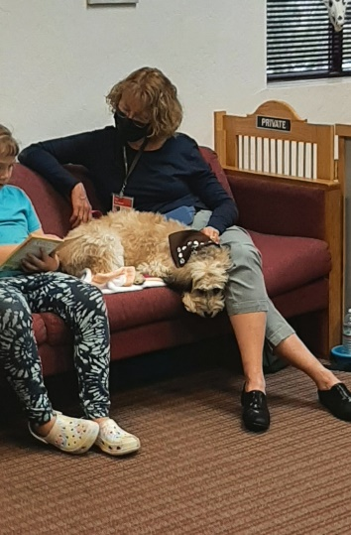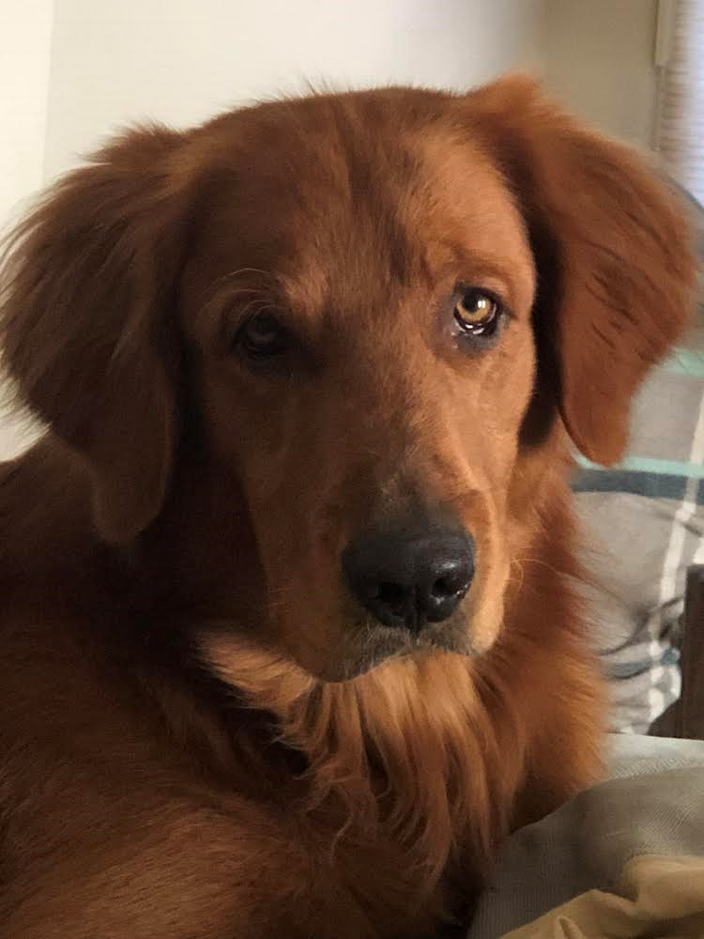**Aug 4, 8, 18, 22 - Sept 1, 12, 15, 26 - Oct 6, 10, 20, 24**

**1st and 3rd Thursdays**   
Ms. Debbie & dog  
🡨 Cooper   
*(later this fall will be Ms. Pat   
& dog Frankie instead) 🡪*

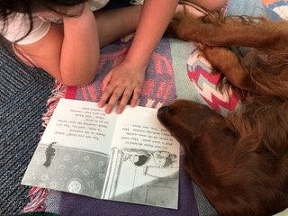**2nd and 4th Mondays**   
Ms. Deb & dog Megan 🡪

*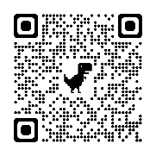***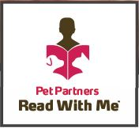**

https://petpartnersofprescott.weebly.com/  
www.chinoaz.net/216/childrens-library  
Chino Valley Public Library, right next to bus drop off at   
Memory Park! 1020 W Palomino Rd Chino Valley AZ 86323  
928-636-2687, RLaurence@chinoaz.net