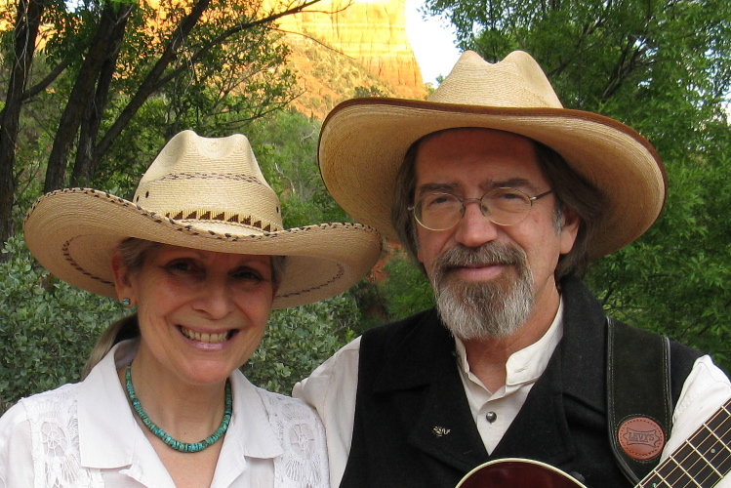
Ken and Lyn Mikell
Harpy Trails

Ken and Lyn Mikell play a wide range of traditional music, with particular attention to the Celtic roots of cowboy music.
Using a wide range of musical instruments, Ken and Lyn animate and illuminate the music and poetry that followed the trail west.
They have been making music together for over thirty years.

