**White Elephant Gift Exchange**

1. **Draw numbers to establish the gift exchange order.**
2. **Sit in a circle and place the gifts in the center, preferably under a festive tree.**
3. **The person who drew #1 selects a gift from the pile. DO NOT UNWRAP IT.**
4. **The person who drew #2 decides whether to steal that gift or pull from the pile of gifts.**
5. **The person who draws #3 can decide to steal someone else’s gift, etc., etc.**
6. **At the end, when ALL the gifts are drawn, #1 gets ONE LAST CHANCE to keep the gift they have or “steal” someone else’s gift.**
7. 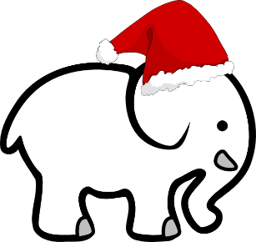**Unwrap your gift!**

**White Elephant Gift Exchange**

1. **Draw numbers to establish the gift exchange order.**
2. **Sit in a circle and place the gifts in the center, preferably under a festive tree.**
3. **The person who drew #1 selects a gift from the pile. DO NOT UNWRAP IT.**
4. **The person who drew #2 decides whether to steal that gift or pull from the pile of gifts.**
5. **The person who draws #3 can decide to steal someone else’s gift, etc., etc.**
6. **At the end, when ALL the gifts are drawn, #1 gets ONE LAST CHANCE to keep the gift they have or “steal” someone else’s gift.**
7. **Unwrap your gift!**